Vacuum clamping fixture for testing SD cards.

An essential prerequisite for checking conventional SD memory cards is the accessibility of these sensitive workpieces from at least 5 sides.

What could be better than a gentle and at the same time repeatable process using a special vacuum clamping device for multiple parts.

32 SD cards are positioned and aligned on a special passepartout. The passepartout is then guided to the correct position by means of two fixed stops, so that the SD cards are accurately placed on matching clamping surfaces.

During measuring, to avoid disturbing contours, the passepartout is simply lowered to the base of the fixture. (see picture)

By activating one valve, all SD cards are now precisely and securely fixed for the measuring process. After measuring is completed, the passepartout together with the SD cards is removed again.

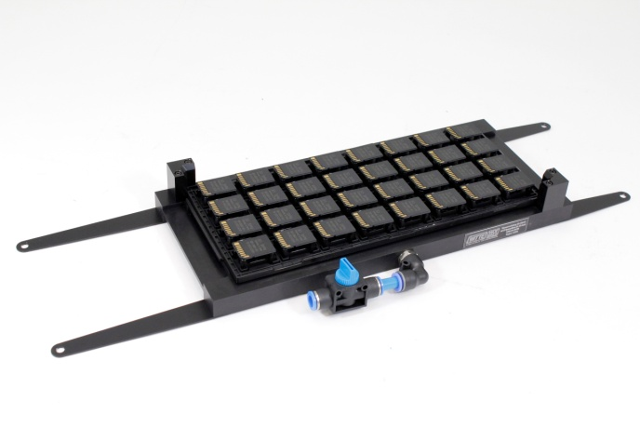

Picture: Vacuum clamping fixture for 32 SD cards